CUSTOMER SERVICE PERFORMANCE & SATISFACTION ANALYTICS

1. Project Overview
Customer service plays an important role in maintaining customer satisfaction and business performance. Organizations receive customer requests through multiple channels such as Phone, Email, Live Chat, WhatsApp, Social Media, and Branches. Managing these tickets efficiently requires an understanding of ticket volume, priority, issue categories, response time, resolution time, customer satisfaction, and geographical patterns.
The objective of this project is to analyze customer service ticket data from the KSA region and transform the raw data into meaningful business insights using Python and Power BI.
The analysis focuses on four major areas:
- Overall customer service performance, Ticket and resolution efficiency, Customer satisfaction, Regional and city-level performance

2. Problem Statement
Customer service teams receive and manage a large number of tickets through different channels and across different issue categories and priorities. Without systematic analysis, it is difficult to identify where workload is concentrated, which issues require more time to resolve, which channels provide a better customer experience, and which unresolved tickets require immediate attention.
The purpose of this project is therefore to transform raw customer service ticket data into meaningful business insights that can support better operational planning, service improvement, and customer satisfaction.

3. Project Objectives
• To clean and preprocess customer service ticket data for accurate analysis.
• To identify important patterns, trends, relationships, and anomalies through exploratory data analysis.
• To analyze ticket performance across priority, issue category, channel, and location.
• To evaluate customer satisfaction using CSAT scores and meaningful visualizations.
• To create an interactive Power BI dashboard and provide actionable business recommendations.

4. Dataset Description
The project uses the Saudi Customer Service Support Tickets 2024–2026 dataset from the Prime Levels Data Hub. The raw dataset contains 1,998 records and 15 columns. It contains both categorical and numerical information related to customer service tickets.
Important fields include ticket ID, customer ID, channel, issue category, priority, assigned agent, city, created date, resolved date, first response time, resolution time, ticket status, CSAT score, and refund amount. After data preparation and feature engineering, the final analytical dataset contains 22 columns.

5. Tools and Technologies Used
• Python and Google Colab were used for data loading, cleaning and EDA
• Pandas was used for data manipulation and aggregation.
• NumPy was used for numerical operations and feature calculations.
• Matplotlib and Seaborn were used for exploratory visualizations and statistical plots.
• Power BI was used for Interactive visualizations

6. Data Preparation and Cleaning
The dataset was first inspected to understand its structure, data types, missing values, and possible duplicate records. Date columns were converted into appropriate datetime formats and numerical fields were validated before analysis. Missing categorical values in fields such as channel, issue category, and city were handled by assigning the value “Unknown” rather than deleting the corresponding records. This preserved the available ticket information while making the missing category explicit. Duplicate records were checked and no duplicate rows were identified. Missing resolved dates were retained because they represent unresolved tickets and therefore contain important business information. Resolution duration was not artificially filled for unresolved tickets.

Derived Fields:
• resolution_status was created to classify tickets as Resolved or Unresolved.
• resolution_days was derived to measure the duration required to resolve applicable tickets.
• created_year, created_month, and created_month_year were created for time-based analysis.
• response_category was created to group first-response performance.
• ticket_age_days was calculated for unresolved tickets using 31 October 2026 as the analysis reference date.

7. Types of Analysis Performed
Descriptive analysis: Used to summarize ticket volume, ticket status, priority, channel, issue category, CSAT, response time, resolution time, and refund amounts.
Diagnostic analysis: Used to investigate differences between categories and understand possible operational reasons behind workload, delays, and customer satisfaction patterns.
Prescriptive analysis: Findings were converted into practical business recommendations. Predictive analysis was not performed in this project.
Univariate analysis: Used to study individual variables such as ticket status, priority, channel, issue category, CSAT distribution, and first response time.
Bivariate analysis: Used to examine relationships between two variables, such as priority and response time, issue category and resolution time, and channel and CSAT.
Multivariate analysis: Used to examine combined patterns involving issue category, priority, channel, ticket volume, resolution performance, and CSAT.
Correlation analysis: Used to measure relationships among response time, resolution time, CSAT, resolution days, and refund amount.

8. PowerBI Dashboard
The Power BI report contains four interactive pages: Overview, Ticket Analysis, Customer Experience, and Location & Regional Analysis. Slicers and bookmark navigation allow users to explore the report according to their area of interest.

9. Overview Dashboard
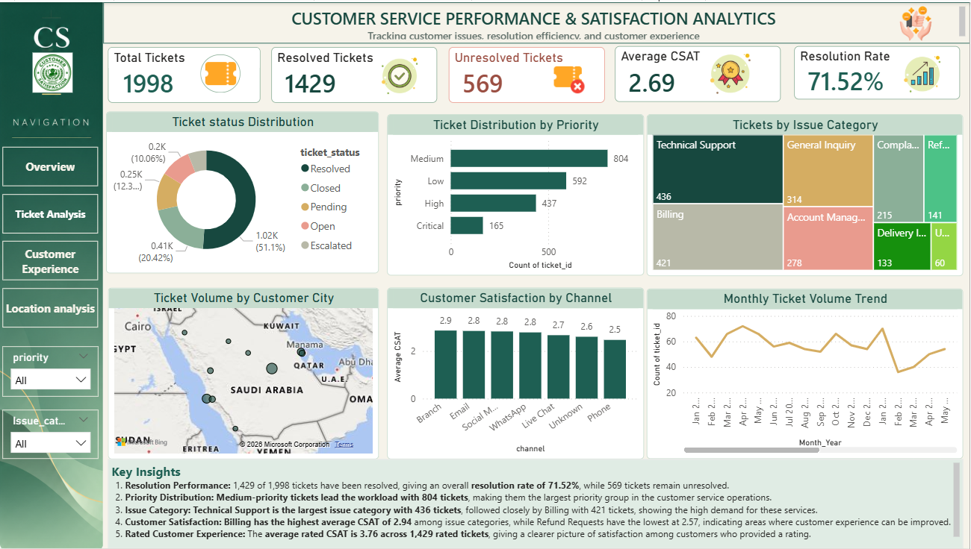
The Overview page provides a management-level summary of customer service performance. It contains five KPI cards: Total Tickets, Resolved Tickets, Unresolved Tickets, Average CSAT, and Resolution Rate.The Total Tickets KPI shows 1,998 tickets. Resolved Tickets are 1,429, while 569 tickets remain unresolved. Average CSAT is 2.69 and the overall Resolution Rate is 71.52%.

Charts Used:
• Ticket Status Distribution: A donut chart shows the composition of tickets across Resolved, Closed, Pending, Open, and Escalated statuses. It is useful for understanding the overall status structure of the workload.
• Ticket Distribution by Priority: A bar chart compares the volume of Critical, High, Medium, and Low priority tickets. Medium priority contains the highest number of tickets.
• Ticket Volume by Issue Category: A treemap shows the relative size of each issue category. Technical Support and Billing represent the largest workload areas.
• Ticket Volume by Customer City: A map provides a geographic view of ticket demand across Saudi cities.
• Customer Satisfaction by Channel: A column chart compares average CSAT across service channels and highlights differences in customer experience.
• Monthly Ticket Volume Trend: A line chart tracks ticket volume over time and helps identify high- and low-volume periods, high in Dec 2025 and low in Feb 2025.

10. Ticket Analysis
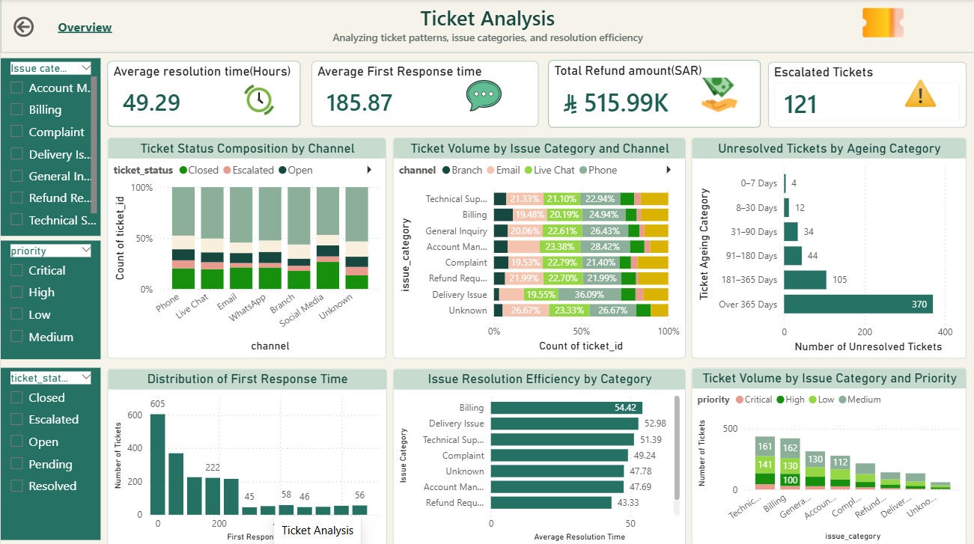
The Ticket Analysis page focuses on operational performance and resolution efficiency. Its KPI cards show an average resolution time of 49.29 hours, an average first response time of 185.87 minutes, total refund amount of approximately SAR 515.99K, and 121 escalated tickets.

Charts Used:
• Ticket Status Composition by Channel: A 100% stacked column chart compares the distribution of ticket statuses within each service channel.
• Ticket Volume by Issue Category and Channel: A 100% stacked bar chart shows how different channels contribute to each issue category.
• Unresolved Tickets by Ageing Category: A bar chart highlights how long unresolved tickets have remained open.
• Distribution of First Response Time: A distribution chart shows how quickly customer service teams respond to tickets.
• Issue Resolution Efficiency by Category: A bar chart compares average resolution time across issue categories. Billing has the highest average resolution time.
• Ticket Volume by Issue Category and Priority: A stacked chart shows how priority levels are distributed within each issue category.

11. Customer Experience
The Customer Experience page focuses on customer satisfaction and service experience. Its KPI cards show an overall Average CSAT of 2.69, Average Rated CSAT of 3.76, 1,429 rated tickets, and an average resolution time of 68.92 hours for rated tickets.

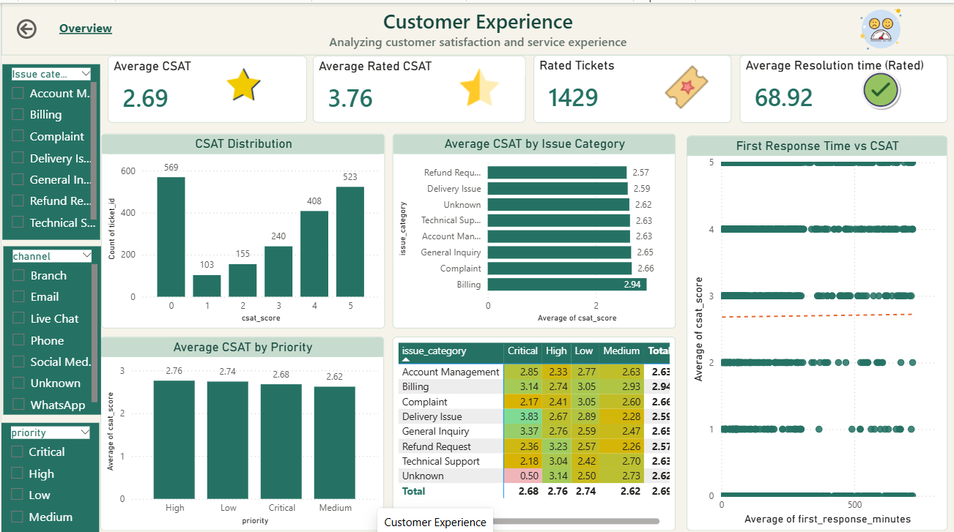

Charts Used:
• CSAT Distribution: A column chart shows the frequency of CSAT scores from 0 to 5 and provides an overall view of the satisfaction distribution.
• Average CSAT by Issue Category: A bar chart compares satisfaction across issue categories. Refund Requests and Delivery Issues have relatively lower average CSAT, while Billing has the highest average among the main categories.
• Average CSAT by Priority: A column chart compares customer satisfaction across priority groups.
• CSAT by Issue Category and Priority: A heatmap shows how satisfaction changes when issue category and priority are considered together.
• First Response Time vs CSAT: A scatter chart examines whether response speed is strongly related to customer satisfaction. The relationship is very weak.

12.Location & Regional Analysis
The Location & Regional Analysis page evaluates service performance across cities. The page identifies 11 cities, Riyadh as the city with the highest ticket volume, Abha as the city with the highest average CSAT, and Buraidah as the city with the highest average resolution time.
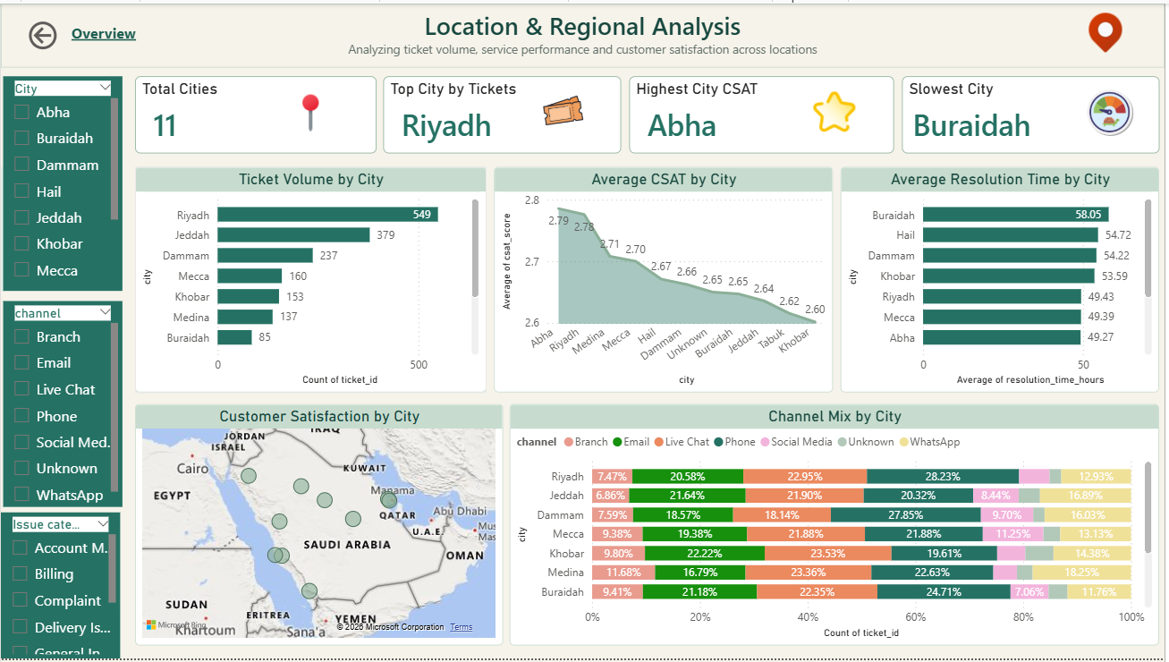

Charts Used:
• Ticket Volume by City: A horizontal bar chart ranks cities by ticket volume. Riyadh has the highest ticket volume.
• Average CSAT by City: An area chart compares average customer satisfaction across cities.
• Average Resolution Time by City: A bar chart identifies cities with slower resolution performance. Buraidah has the highest average resolution time.
• Customer Satisfaction by City: A map provides geographic context for customer satisfaction.
• Channel Mix by City: A 100% stacked bar chart shows how different service channels are distributed across cities.

13. Key Insights
• Priority has a strong effect on response performance. Critical tickets receive an average first response in 14.82 minutes, while Low-priority tickets average 373.60 minutes.
• Technical Support and Billing are major workload areas. Technical Support contains 436 tickets and Billing contains 421 tickets, making both important areas for resource planning.
• Billing has the highest average resolution time. Billing averages approximately 54.42 hours, indicating a potential process bottleneck that should be investigated.
• First response time has almost no linear relationship with CSAT. The correlation between first response time and CSAT is approximately 0.01, showing that response speed alone does not explain customer satisfaction.
• Customer experience varies across channels and locations. Phone has an average CSAT of 2.47, while Abha has the highest city-level CSAT at approximately 2.79.

14. Business Recommendations
• Implement priority-based response SLAs. Define clear response targets for each priority level and monitor tickets that exceed those targets.
• Allocate resources to Technical Support and Billing. Staffing and specialist capacity should reflect the high workload in these categories.
• Improve Billing resolution efficiency. Investigate approval processes, verification steps, refund handling, and other causes of long resolution times.
• Improve the Phone support experience. Review waiting time, agent handling, escalation practices, and first-contact resolution performance.
• Focus on resolution quality, not only response speed. Customer service performance should be evaluated using both operational KPIs and customer-experience measures.

15. Conclusion
This project demonstrates how Python-based exploratory and diagnostic analysis combined with Power BI can transform raw customer service ticket data into actionable business intelligence. The analysis identifies important workload patterns, service delays, customer satisfaction differences, and ageing unresolved tickets. The findings show that improving customer service requires more than faster first responses. A balanced approach is needed that combines priority-based SLAs, efficient resolution processes, appropriate resource allocation, channel improvement, and active backlog management. The Power BI dashboard makes these insights accessible through an interactive and management-friendly reporting environment.

